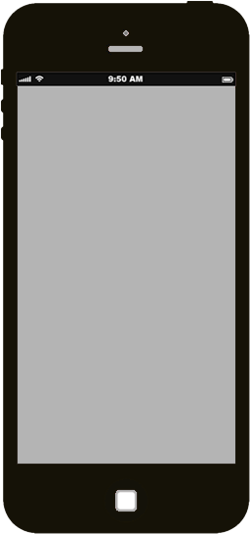

Double-click a ToDo item to edit it

Created by James Thomas and  Ed Chatelain

Part of TodoMVC

*What needs to be done?*

**ToDos**